SMART SOLUTION FOR RAILWAYS

TEAM ID:PNT2022TMID35794

SPRINT-4: WEATHER AND LOCATION:

NODE RED:

BACK-END SCREENSHOTS:
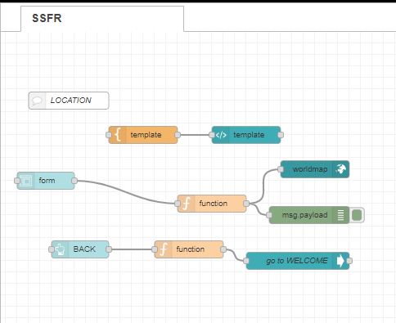
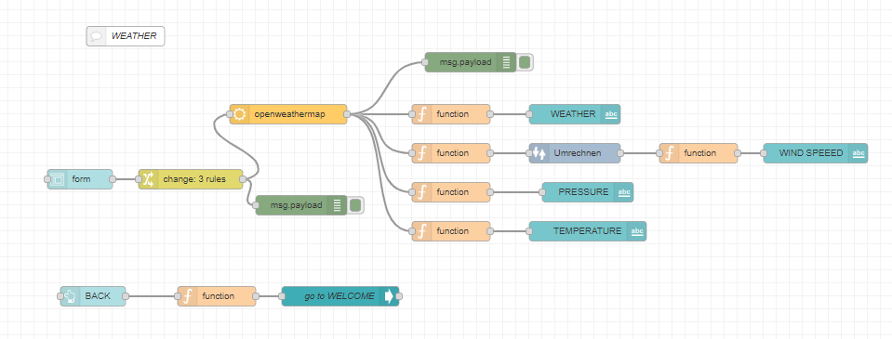

WEATHER SCREEN:
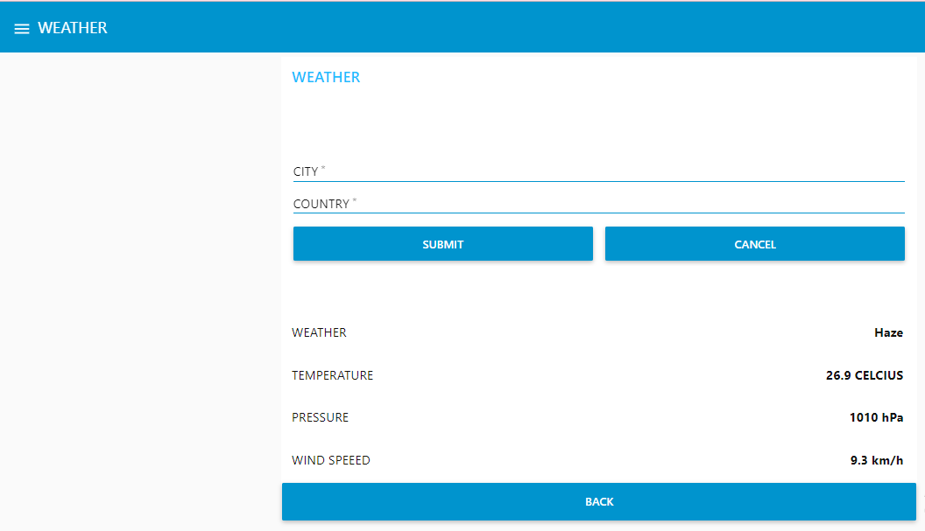

LOCATION SCREEN:
